Descriptive (Semantic) Markup Language

🧠 What is a Descriptive (Semantic) Markup Language?
# Source: AI Source: Provided by: [Data Path: Persons Table -> ID Column: 1, Name_En Column: Motasem Essam] -> From: [Chatgpt (GPT‑5 Mini)] on [1/26/2026]
Descriptive, or semantic markup, is a type of markup that tells what the content means, not how it looks.

🔹 Key Idea:
# Source: AI Source: Provided by: [Data Path: Persons Table -> ID Column: 1, Name_En Column: Motasem Essam] -> From: [Chatgpt (GPT‑5 Mini)] on [1/26/2026]
Semantic markup describes the role or meaning of the content (like title, paragraph, section) so machines and humans can understand its structure and purpose.

📄 Example in HTML (Semantic Markup)
# Source: AI Source: Provided by: [Data Path: Persons Table -> ID Column: 1, Name_En Column: Motasem Essam] -> From: [Chatgpt (GPT‑5 Mini)] on [1/26/2026]
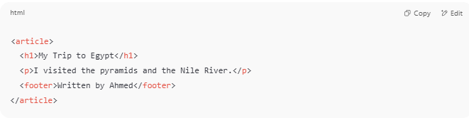
<article>
<h1>My Trip to Egypt</h1>
<p>I visited the pyramids and the Nile River.</p>
<footer>Written by Ahmed</footer>
</article>

- <h1> = main heading
- <p> = paragraph
- <footer> = content at the end
- <article> = standalone piece of content
🧠 This tells the browser, search engines, and screen readers what each part of the page is — not how it should look.

🔸 Common Semantic Tags in HTML
# Source: AI Source: Provided by: [Data Path: Persons Table -> ID Column: 1, Name_En Column: Motasem Essam] -> From: [Chatgpt (GPT‑5 Mini)] on [1/26/2026]
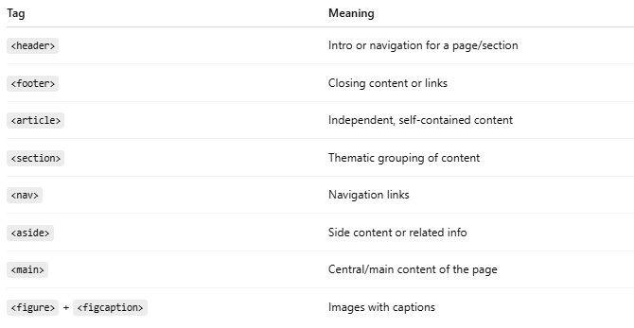
Tag | Meaning
<header> | Intro or navigation for a page/section
<footer> | Closing content or links
<article> | Independent, self-contained content
<section> | Thematic grouping of content
<nav> | Navigation links
<aside> | Side content or related info
<main> | Central/main content of the page
<figure> + <figcaption> | Images with captions

📑 Example in XML (Semantic Data Markup)
# Source: AI Source: Provided by: [Data Path: Persons Table -> ID Column: 1, Name_En Column: Motasem Essam] -> From: [Chatgpt (GPT‑5 Mini)] on [1/26/2026]
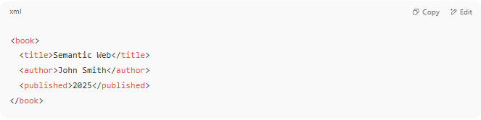
<book>
<title>Semantic Web</title>
<author>John Smith</author>
<published>2025</published>
</book>

- Tags like <title> and <author> describe the type of data — not how to display it.

🟢 Why Use Semantic Markup?
# Source: AI Source: Provided by: [Data Path: Persons Table -> ID Column: 1, Name_En Column: Motasem Essam] -> From: [Chatgpt (GPT‑5 Mini)] on [1/26/2026]
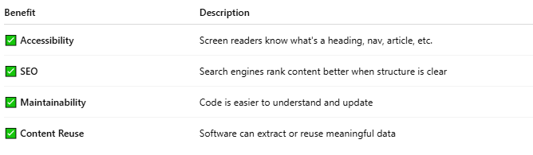
Benefit | Description
✅ Accessibility | Screen readers know what's a heading, nav, article, etc.
✅ SEO | Search engines rank content better when structure is clear
✅ Maintainability | Code is easier to understand and update
✅ Content Reuse | Software can extract or reuse meaningful data

❌ What It Doesn’t Do:
# Source: AI Source: Provided by: [Data Path: Persons Table -> ID Column: 1, Name_En Column: Motasem Essam] -> From: [Chatgpt (GPT‑5 Mini)] on [1/26/2026]
- It does not style the content. Styling is handled by CSS.
- It doesn't tell how the content should appear visually.

✅ Summary
# Source: AI Source: Provided by: [Data Path: Persons Table -> ID Column: 1, Name_En Column: Motasem Essam] -> From: [Chatgpt (GPT‑5 Mini)] on [1/26/2026]
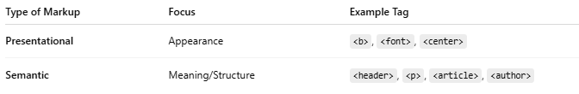

Type of Markup | Focus | Example Tag
Presentational | Appearance | <b>, <font>, <center>
Semantic | Meaning/Structure | <header>, <p>, <article>, <author>

